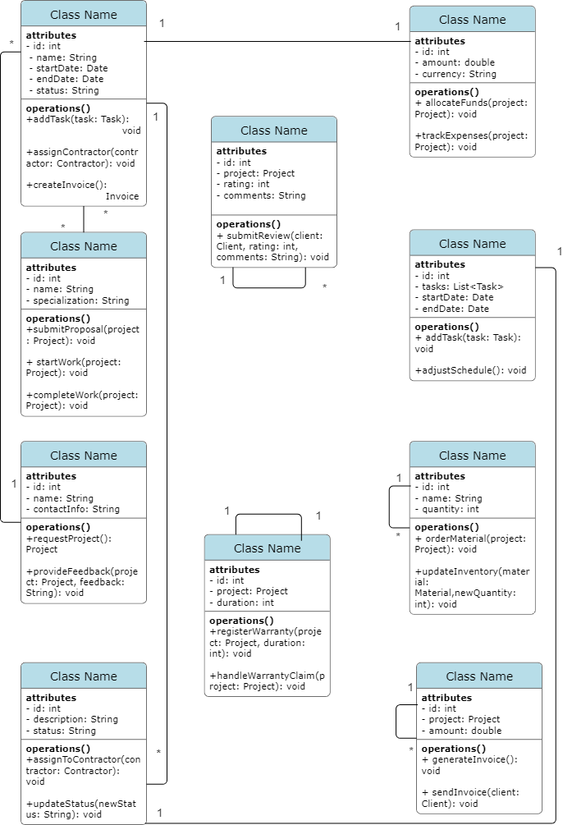

**Home Renovation Planner**

**Problem Statement :**

In today's fast-paced world, homeowners often find it challenging to manage and execute home renovation projects efficiently. From planning and budgeting to finding reliable contractors and ensuring timely completion, the process can be overwhelming and stressful.

The Home Renovation Planner aims to address these challenges by providing homeowners with a comprehensive platform to plan, organize, and manage their renovation projects seamlessly. The platform will leverage advanced technologies, including AI-powered chatbots, to streamline the renovation process and enhance the overall experience for homeowners.

**Requirements :**

1. **Project:**

* Each project should have a unique identifier.
  + - It should include details such as project name, address, start date, end date, and current status.
    - Projects should be associated with one client and one contractor.
    - The project should have a budget allocated to it.
    - It may have multiple tasks associated with it.
    - It may have an invoice generated upon completion.
    - It may have a review submitted by the client.

1. **Contractor :**
   * + Each contractor should have a unique identifier.
     + Contractors should have a name, company name, and license number.
     + They should be able to accept and execute projects assigned to them.
     + Contractors should be associated with one or more projects.
2. **Client :**
   * + Each client should have a unique identifier.
     + Clients should have a name, address, and contact information.
     + They should be able to initiate and manage multiple projects.
     + Clients should be associated with the projects they initiate.
3. **Task :**
   * + Each task should have a unique identifier.
     + Tasks should have a description and estimated duration.
     + They should be associated with a project.
     + Tasks may have an actual duration and status (e.g., pending, in progress, completed).
     + Tasks may have reviews associated with them.
4. **Budget :**

* Each budget should have a unique identifier.
* It should be associated with a specific project.
* The budget should track expenses and compare them against the allocated amount.

1. **Schedule :**

* Each schedule should have a unique identifier.
* It should be associated with a specific project.
* The schedule should include a list of tasks with assigned start and end dates.

1. **Material :**

* Each material should have a unique identifier.
* Materials should have a name, quantity, and unit price.
* They should be associated with one or more tasks.

1. **Invoice :**

* Each invoice should have a unique identifier.
* It should be associated with a specific project.
* The invoice should include the total amount due, due date, and payment instructions.

1. **Review :**

* Each review should have a unique identifier.
* Reviews should include a rating and comments.
* They should be associated with a specific project or task.

1. **Warranty :**

* Each warranty should have a unique identifier.
* Warranties should include the duration and terms of coverage.
* They should be associated with a specific project.